The HBP Calls for Expression of Interest for SGA3

“EBRAINS Infrastructure Training”

Proposal Template

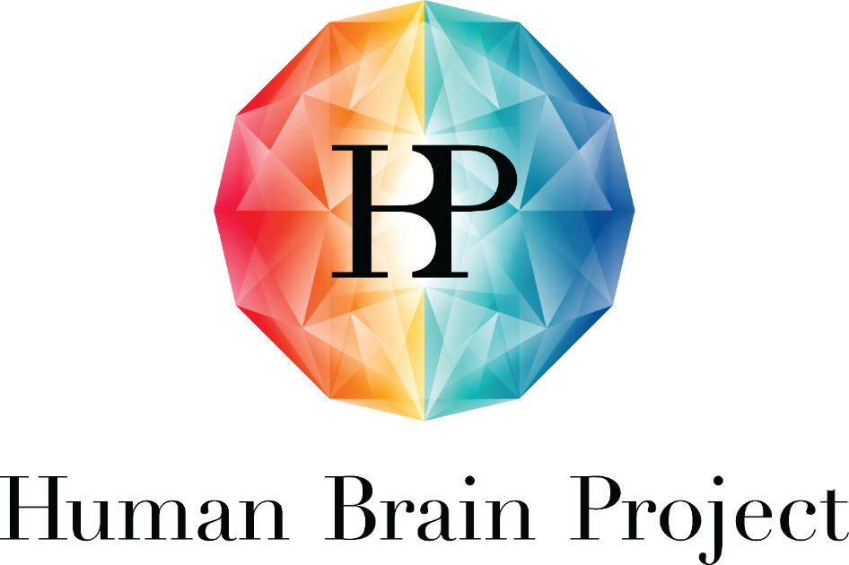

Project Number: | 945539 | Project Title: | Human Brain Project SGA3

Document Title: | HBP CEoI for SGA3 – EBRAINS Infrastructure Training – Proposal Template
Document Filename: | HBP Proposal template EBRAINSInfraTraining.docx
Dissemination Level: | PU = Public
Author(s): | Laura SAXER, MUI (P42)
Compiled by: | Laura SAXER, MUI (P42)
Contributor(s): | Judith KATHREIN, MUI (P42)  Tina KOKAN, MUI (P42)
Editorial Review: | Annemieke MICHELS, EPFL (P1)
Abstract: | Calls for Expression of Interest for SGA3, Proposal Template to submit a proposal to organise an EBRAINS Infrastructure Training event.
Keywords: | Hands-on training, interdisciplinary, neuroscience, ICT, brain medicine
Target Users/Readers: | PIs from the scientific community, inside and outside the HBP Consortium
Call Publication Date: | 09.06.2020
Proposal Submission Deadline: | The Call is permanently open and proposals will be evaluated as they are submitted.
Call topic | EBRAINS Infrastructure Training
Total budget/human recourses | Up to EUR 9,000 contributed by the HBP Education Programme Office and 1 person-month from HBP Education Programme Office staff, per event.
More information: | training-support@humanbrainproject.eu
Proposal submission | HBP Open Call Platform

Instructions:
This template is for proposals made in response to the HBP CEoI for SGA3 “EBRAINS Infrastructure Training”.
This form must be submitted electronically as a single PDF file in English to the HBP open call platform.
Instructions (in red) can be deleted.
Table of Contents

1. Proposal information 5
2. Date 5
3. Abstract 5
4. Objectives and character 5
5. Type of event 5
6. EBRAINS Service Categories 5
7. Information on applicant & administrative contact person 6
8. Detailed programme draft schedule 7
9. Speaker/faculty information 8
10. Estimated budget and costs applied for 8
11. Administrative support requested from HBP Education Programme Office 8
12. Information on diversity aspects 9
13. Terms and Conditions: 9
Annex: The Human Brain Project Outcomes in SGA3 10

Table of Tables

Table 1: Applicant 5
Table 2: Scientific Chair 5
Table 3: Administrative contact person 6
Table 4: Programme schedule 6
Table 5: Speaker(s) 7
Table 6: Budget 7
Table 7: Human Brain Project Outcomes in SGA3 9

Proposal information
Proposal name: 80 characters maximum, spaces included. Do not use abbreviations or Greek characters
Proposal acronym:

Date
Provide the date of the event.

Abstract
1,000 characters maximum, spaces included. Do not use abbreviations or Greek characters.

Objectives and character
min. 1-2 sentences per question
- What are the learning outcomes for participants (including complementary skills)?
- Explain the interactive nature of the event.
- How are the new HBP Outcomes of SGA3 linked to the programme? How is this event contributing to increasing the number of EBRAINS infrastructure users?
- How will participation of an expected number of participants be achieved (e.g. specific dissemination or target groups)?

Type of event
Indicate which of the following applies to your proposed event:
- Training event taking place virtually via web conferencing software (e.g. webinars, online training)
- Training event taking place alongside the major EBRAINS national and international Outreach and Educational events (e.g. HBP Summits, EBRAINS Workshops, large National Engagement events)
- Training event taking place alongside external research and scientific events (e.g. as a satellite workshop at a conference)
- Training event that is an established EBRAINS training event, e.g. CodeJams, Hackathons, tool and service trainings, etc.

EBRAINS Service Categories
Indicate which of the following EBRAINS Service Categories are showcased by the proposed Training.
- SC1: Curated and shared data: EBRAINS FAIR data services - neuroscience data publishing
- SC2: Brain atlas services: navigate the brain in 3D - find, contribute and analyse brain data, based on location
- SC3: Brain modelling and simulation workflows: integrated tools to create and investigate models of the brain
- SC4: Closed loop AI and robotics workflows: design, test and implement robotic and AI solutions
- SC5: Medical brain activity data platform: human intracerebral EEG database and analysis service
- SC6: Interactive workflows on HPC or NMC: Europe-wide access to scalable and interactive compute services

Information on applicant & administrative contact person
Insert name, affiliation and contact details of the applicant, as well as the administrative contact person for the event
- Note: The applicant is responsible for submitting the proposal and is the contact person for the HBP Education Programme Office regarding the scientific programme and speakers. If the applicant is not the Scientific Chair, please list the Scientific Chair separately.
- Note: The administrative contact will be the contact person for the HBP Education Programme Office regarding logistics and questions during the planning of the event. Administrative contact persons can be administrative assistants, students, post-docs, as well as the Scientific Chair.
Table 1: Applicant
Applicant
Last name
First name
Gender | male female other
Title (Dr, Prof)
Organisation type | - HBP Partner University  - HBP Partnering Project  - Non-HBP University  - Other organisation/company
Affiliation (university/company)
HBP Work Package (if applicable)
Country
E-mail address (mandatory)
Table 2: Scientific Chair
Scientific Chair (if not same person as applicant)
Last name
First name
Gender | male female other
Title (if applicable)
Organisation type | - HBP Partner University  - HBP Partnering Project
Affiliation (university/company)
Country
HBP Work Package
E-mail address (mandatory)
Table 3: Administrative contact person
Administrative contact person
Last name
First name
Gender | male female other
Title (if applicable)
Profession
Organisation type | - HBP Partner University  - HBP Partnering Project  - Non-HBP University  - Other organisation/company
Affiliation (university/company)
Country
HBP Work Package (if applicable)
E-mail address (mandatory)

Detailed programme draft schedule
In this section, a detailed programme must be outlined. The draft programme schedule should include:
- Tentative title/topic
- Short description
- Format (e.g. lecture, hands-on session, tutorial, discussion, etc.) and duration
- Confirmed speaker(s) to cover the sessions
The draft schedule should be followed by a short description on how sessions relate to each other and follow a common thread.
Table 4 can be used as an example for drafting a programme schedule:
Table 4: Programme schedule
 | Session title | Session format and duration | Description | Name(s) of speaker(s)
Session 1 | The Human Brain Project at the half-way point | Lecture 30 minutes, Q&A 10 minutes | Introduction and overview of the HBP, its objectives, Project structure, results and outlook for the remainder of the Project’s funding periods. | Alois SARIA
Session 2 | … | … | … | …

Speaker/faculty information
Provide the following information for each of the proposed speakers/faculty (do not use abbreviations or Greek characters):
Table 5: Speaker(s)
Speaker 1
Last name
First name
Gender | male female other
Title (Dr, Prof)
Organisation type | - HBP Partner University  - HBP Partnering Project
Affiliation (university/company)
E-mail address (mandatory)
Copy Table 5 for each speaker (Speaker1, Speaker2, …. etc.).

Estimated budget and costs applied for
Provide a costs estimation and indicate the final budget applied for.
Table 6 (with examples) can be used as a template for drafting a budget. Additional cost items can be listed.
Table 6: Budget
Cost category | Cost explanation | Sum
Speaker travel | EUR per speaker per roundtrip within Europe
Speaker accommodation | EUR per night
Catering | EUR per participant
Venue | EUR rent per day
Total costs
HBP Education Programme Office contribution | Total sum of financial support applied for in the context of this Training proposal.
Tuition fees | Approximately EUR per participant (if applicable)
Total revenue

Administrative support requested from HBP Education Programme Office
Indicate which of the following support offers by the HBP Education Programme Office you would like to request for your event.
- Outreach and promotion of event (newsletter, social media, event calendars)
- General advice about event organisation (planning, lessons learnt, important details)
- Preparation of event materials (e.g. design of event announcement and on-site programme)
- Handling of registration and collection of tuition fees (if required)
- Management of financial support (handling of refunds of travel costs)
- On-site administrative support (if required)
- On-site media support (photographing, video recording if required)
- Post-processing of event (photo and video editing, workshop survey)
- Event report

Information on diversity aspects
(min. 2-3 sentences)
The HBP as European Flagship project pays specific attention to the gender balance of speakers as well as to how gender and diversity are addressed as research content (e.g. by differentiating sex of cells and tissues, age and/or social background of patients or users). Differentiating variables has been recognised to be relevant in brain research, robotics, and AI alike – from the level of stem cells to avoiding the replication of stereotypes due to the use of data without reflection.
In this section, the submitters’ considerations on how to include aspects of diversity and ethics in the event should be outlined.

Terms and Conditions:
If the proposal is selected, a Memorandum of Understanding (MoU) is signed between the applicant and the HBP Education Programme Office (and the Scientific Chair if not same person as applicant). The applicant (and Scientific Chair) commits to responsiveness during the organisation of the event. During the first planning video conference (VC), all steps for the event support will be agreed upon.
By submitting a proposal, the applicant (and Scientific Chair) agrees to these Terms and Conditions.

Annex: The Human Brain Project Outcomes in SGA3
Table 7: Human Brain Project Outcomes in SGA3
Human Brain Project Outcomes in SGA3
OC1. Thanks to the HBP achieving PO1, EBRAINS will facilitate access to and the enrichment of research tools, allowing constantly updated knowledge on brain function and brain-derived AI to be quickly shared across Europe, leading to a considerable increase in the amount of scientific data, educational material and research on advanced AI produced by the communities.
OC2. Thanks to HBP activities that support massively parallel execution of virtual experiments on high-performance computers (including modelling and simulation of the brain as well as neurorobotics), basic brain science will explore new avenues and new industry-driven research will be launched on devices such as implants and prostheses, as a direct outcome of PO1, PO3 and PO5.
OC3. Thanks to EBRAINS simulation services (including their many analytical workflows (PO3) and data security measures), there will be a rapid change in how the brain research community manages and uses its data and, consequently, an increase in research into multi-level brain complexity (in space and time), hopefully leading to related new discoveries.
OC4. Thanks to EBRAINS Atlas tools for combining, analysing and integrating brain data in 3D space (PO2), interventions in patients’ brains will be better guided. In particular, thanks to the Human Brain Atlas, neurologists and neurosurgeons in clinical practice will be able to develop a wide range of tools for preparing personalised brain models for patients undergoing surgery (such as the TVB application for epilepsy patients). They will also start to provide software for stereotaxic interventions, such as deep brain stimulation (DBS) in patients with Parkinson’s, or to support surgery on brain tumors, by providing microstructurally plausible information on target brain regions.
OC5. Thanks to the building blocks offered by the EBRAINS Neurorobotics Platform (PO1), roboticists will be supported throughout the whole robot development process; from initial design, to simulation for the development of controllers, through to the final 3D print. As a result, they will be able deliver new, low-cost, special-purpose robots built on demand; particularly for medical use-cases, where they might simply be discarded after a single use.
OC6. Thanks to the HBP’s contributions and leading role envisaged in PO7, the International Brain Initiative will deliver solid neuroethics guidance to neuroscience projects in the world; in particular, regarding the ethics of large neuroscience research infrastructures.
OC7. Thanks to HBP findings, including theoretical models and related simulations, new clinical settings will be explored to assess the level of consciousness in patients with consciousness disorders (e.g. comatose patients) and sets of information will be proposed for supporting prognosis and therapeutic decision-making (PO4, PO6).
OC8. Thanks to HBP efforts in translating neuroscientific knowledge into medicine (PO6), a new clinical procedure will be trialled for epilepsy patients, building on the current EPINOV study in France, and a multi-centre, preclinical study of rare diseases will be launched.
OC9. Thanks to EBRAINS making available new, high-performance, closed-loop functions based on insights into human cognition (PO5), industry will be able to develop advanced prototypes for industrial and service robots, advanced autonomous systems, or protheses, e.g., for the visually impaired.

The Human Brain Project Outcomes in SGA3 can be found in the Annex and used for reference.

